
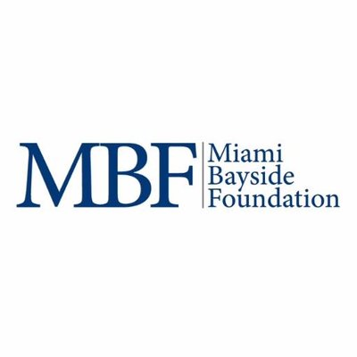

Miami Bayside Foundation
SCHOLARSHIP APPLICATION
2018-2019

Student Name:_____________________________________

Mailing Address: _____________________________________________________________
_____________________________________________________________

Home Phone #: (_____) ___________________ Work Phone #: (_____) ______________

MD ID#:_______________ Campus: ______________ E-Mail Address: __________________

Date of Birth: ____________ Sex: ___ Marital Status: _________________

Ethnicity: (please circle) W B H A I O High School Attended: ______________________

Citizenship: U.S. Citizen___ Perm. Resident: ____ Visa:___ Other:____________

Legal Residence: County: _______________________ State: ________________________

Cumulative GPA: _______ Program GPA: ______

Expected Graduation Date: _________ Degree Program: (please circle) AA AS BS Other______

Major: _____________________________

Have you applied for Financial Aid for 2018-2019? (Please circle) Yes No

Are you employed? (Please circle) Yes No

_____________________________________ ______________________________
Student Signature Date

MAIL this completed form to: David Medina, Scholarship Director
Due Date: September 14th, 2018 Miami Dade College
District Financial Aid Office – Room 1127
11011 SW 104th Street Miami, FL 33176


MIAMI BAYSIDE FOUNDATION SCHOLARSHIP

SCHOLARSHIP CRITERIA:

- A student enrolled in or accepted for admission to Miami Dade College with an interest in business, leadership, and/or entrepreneurship.
- The scholarship is open to a student enrolled in any degree or certificate program.
- U.S. citizens or permanent residents
- City of Miami residents (City of Miami Commission Districts and Zip Codes is attached for further assistance in determining residency).
- Minorities, as defined in the Florida Statutes 288.703(4).
- Demonstrated financial need based on federal financial aid standards (must have filed FAFSA for 2018-2019).
- A cumulative grade point average of at least 2.5 at the College or, if newly enrolled at the College, at prior institutions attended.
- Complete a 250-word-essay that demonstrates the student’s interest in business and entrepreneurship.
- The award amount per student will be $1,000 (12 credits or more) or $500
                - (credits between 6 – 11)
- This scholarship may be renewable if student maintains eligibility.

SELECTION PROCEDURE:

The final recipients will be chosen principally on the basis of academic performance or potential and the extent of unmet financial need. Students will be required to attend a photoshoot a Saturday morning in October or the scholarship will be forfeit. Decisions for this scholarship will be made during September of this year.

All mailed applications must be postmarked no later than September 14th, 2018.



